ELEC 442/6601: Digital Signal Processing

Instructions:
- Students are allowed one double-sided 8.5×11 inch formula sheet. Anything can be written on it. Non-programmable calculators are also allowed.
- Graduate students should attempt all six questions. Undergraduate students will do the first four questions plus either Q5 or Q6.

- (20 marks) The system function H(z) of a causal LTI system has the pole-zero configuration shown in Fig.1. It is known that H(z)=6 when z=1.
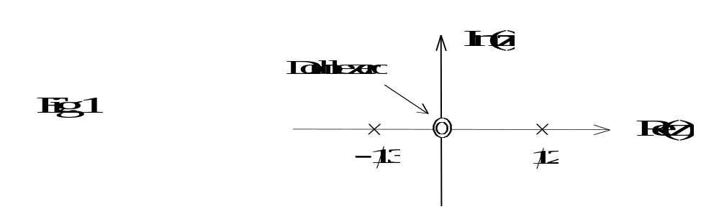
  - Determine H(z).
  - Determine the impulse response h(n) of the system.
  - Determine the response of the system to the input signal 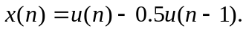
  - If the input x(n) is obtained from sampling the continuous-time signal
at sampling frequency 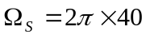 rad/s, determine the output of the system.

- (20 marks) An LTI system is described by the following difference equation
  - Determine the magnitude and phase responses of the system.
  - Assuming that a=0.6, choose the parameter b such that the maximum value of |H(e^{jω})| is unity.
  - Using the result from part (b), determine the output of the system to the input signal 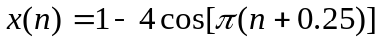.

- (20 marks) A discrete-time signal s(n) has passed through a distortion system. The distorted signal is given by
.
  - Determine the range of value a such that s(n) can be recovered by using a stable and causal inverse system. Give the transfer function of the inverse system.
  - If the value of a doesn’t fall within the range required in part (a), can the distortion be compensated by using a stable and causal LTI system? If your answer is yes, give the transfer function of the LTI system. If no, explain why.

- (20 marks)
        - Let a length-16 sequence be given by x(n)=cos(πn/4), 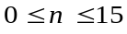. Determine and sketch the 16-point DFT X(k).
        - Given a length-N sequence x(n) 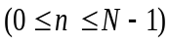 with its N-point DFT X(k) 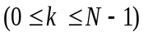, consider a length-2N sequence y(n) 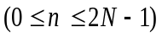 which is given by
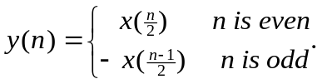
Express the 2N-point DFT Y(k) of y(n) in terms of X(k).
- (20 marks) Consider the system shown in Fig.2, where 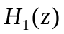 and 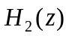are, respectively, ideal zero-phase real-coefficient lowpass and highpass filters with frequency responses as indicated in Fig.3 (a) and (b). If the input is a real sequence with its Fourier transform shown in Fig.3 (c), determine and sketch 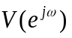, 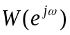, 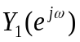 and 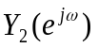. Also express 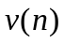 and 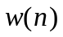 in terms of 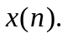

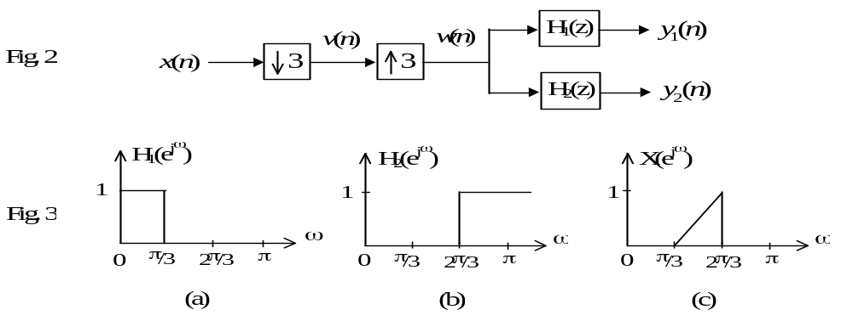

- (20 marks)
  - A causal unstable IIR system is given by
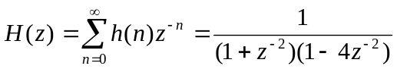.
Let g(n)=a^{n}h(n). Determine the range of value a such that G(z) is causal and stable.
  - Given z(t)=[x(t)+y(t)]², where x(t) and y(t) are band-limited signals with highest frequencies f_{m} and 3f_{m} Hz, respectively. Determine the minimum sampling frequency for z(t) in order to avoid aliasing.
  - Suppose you have a Matlab function to compute N-point DFT. Describe how to compute N-point IDFT using this function.

  - The following system is to change the sampling rate by a noninteger factor. Express v(n) and y(n) in terms of x(n) as well as V(e^{jω}) and Y(e^{jω}) in terms of X(e^{jω}).
